**Day 2 Lab Assignments**

**Use CSS and CSS3 styles to do the following:**

(Note: You can use this this site for search for any image you want to the assignments: <https://www.shutterstock.com>).

1. Make a navbar with rounded corners, and use Font awesome, to add some icons to the navbar items.



* 1. Use the icons from Font awesome.
  2. Make the navbar items as list (ul), and inside each list item (li), add a link for each menu item.
  3. Use list style type: none for the list items.
  4. Use display: inline-block for the list items. (Why?).
  5. Handle that when mouse over an item its background color to be changed, and the icon color also to be changed gradually (Use transition).

1. Use Custom font for any paragraph (Search for new fonts, Do not use the font given in the lecture)
   1. Search for online fonts libraries (google fonts for example) and use them.
2. Make contact chip like this one:

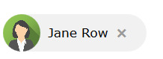

* 1. When user clicks (x) the div next to the image should be closed to the left gradually (use transition or animation and play it using JS), and when click the image it opens again

1. Make a div and write your name on it and make it appears vertical on the page and fill the page height (use transformation).

Like the following image:

1. ----Make simple photo gallery, and use transition to make the photos zoom outs with animation on hover (Use transform: scale() with transition).



1. Use transition to make animated search input that its width will increase gradually on focus, and returns to its normal width gradually on blur
2. -----Use the given tiger Image, and make a waling tiger in the background of the body from left=0 to the right, and when it reaches the page end it flips left and back again (Use CSS only [animation]).
3. Use CSS3 columns on any paragraph.
4. Complete Day.1 Assignment.3, and use awesome fonts for the icons, as the following:

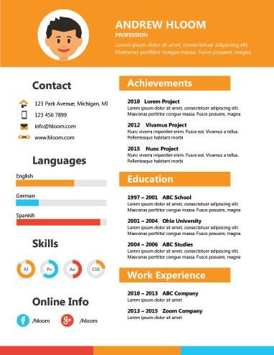

**Enrich your Skills (Big Bonus):**

1. What’s **BEM**? Explain using Demo.
2. What’s **Material Design**? Explain using Demo.

**Bonus Assignments:**

1. In Assignment No.2, Make the contact chip when clicked expands down slowly and display more data (phone, email,…)



1. Make contact card with rounded corner and shadow, like the following:

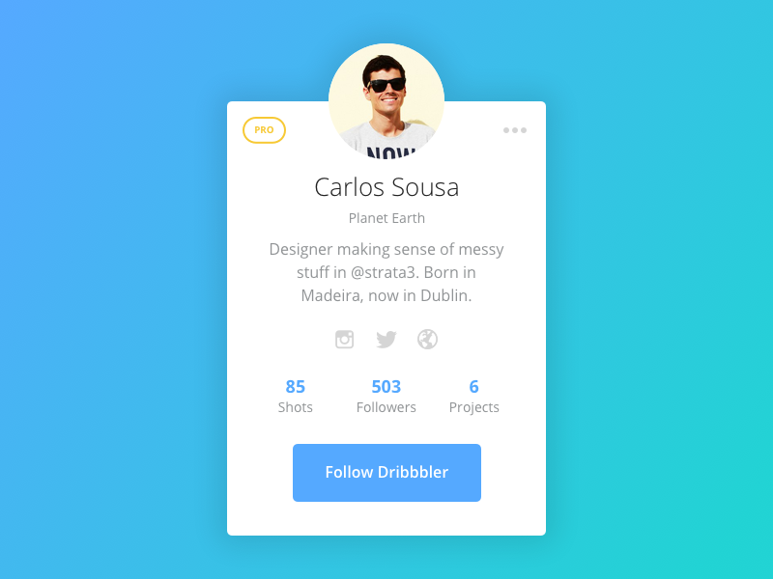

1. Design products list (for E-commerce website) like the following (or like souq.com for example).

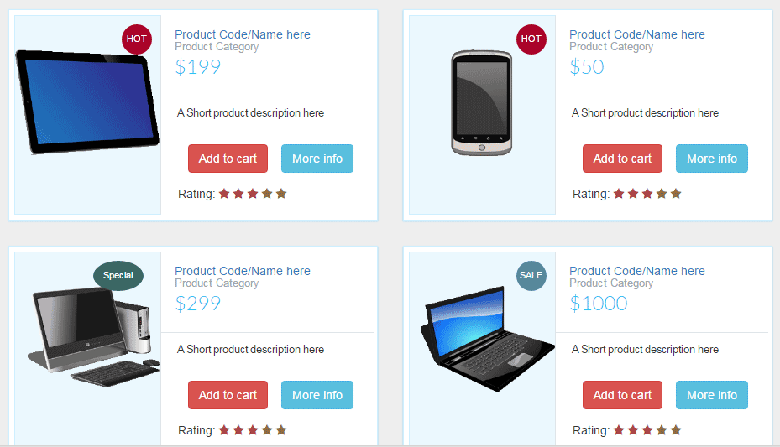

1. Innovate in your CV page, and use animation on it!
2. In assignment.4, when user click the vertical divs, make it show its content.
3. Make a hoverable button like the following: <https://www.w3schools.com/css/tryit.asp?filename=trycss_buttons_hover> (Follow the demo, and then redo it yourself).
4. Make page elements animation with the page scroll like the following: (<https://ihatetomatoes.net/demos/one-page-scroll-animations> ), and you can follow the following tutorial: <https://css-tricks.com/aos-css-driven-scroll-animation-library>
5. Make a demo on CSS animation and upload it CodePin.io
6. Use CSS transition and animation to make a slider in your home page header.
7. Use CSS transition and animation to make a rolling news bar.
8. Search for CSS3 new features and use it.
9. Use the given tiger Image, and make it starts with left 0, and looks at left corner, and on hover on it, rotates to right (looks at right corner), and moves to right (Use CSS only [transform and transitions]).
10. Redo the previous assignment, and make the tiger when arrives to the right corner, reverse the animation, and so on (Use animation instead of transform).
11. Review the following CSS demos and code snippets and then redo them by yourself:
    * <https://www.w3schools.com/css/tryit.asp?filename=trycss_buttons_hover>
    * <https://www.w3schools.com/howto/howto_css_switch.asp>
    * <https://www.w3schools.com/howto/howto_css_loader.asp>
    * <https://www.w3schools.com/howto/howto_css_timeline.asp>
    * <https://www.w3schools.com/howto/howto_css_tooltip.asp>
    * <https://www.w3schools.com/howto/howto_js_popup.asp>
    * <https://www.w3schools.com/howto/howto_js_todolist.asp>
    * <https://www.w3schools.com/howto/howto_css_overlay.asp>
    * <https://www.w3schools.com/howto/howto_js_alert.asp>
    * <https://www.w3schools.com/howto/howto_css_pagination.asp>
    * <https://www.w3schools.com/howto/howto_css_modal_images.asp>
    * <https://www.w3schools.com/howto/howto_js_tab_img_gallery.asp>
    * <https://www.w3schools.com/howto/howto_css_image_overlay.asp>
    * <https://www.w3schools.com/howto/howto_css_pricing_table.asp>
    * <https://www.w3schools.com/howto/tryhow_css_parallax_demo.htm>
    * <https://css-tricks.com/aos-css-driven-scroll-animation-library>

**<Thank>YOU </Thank>**